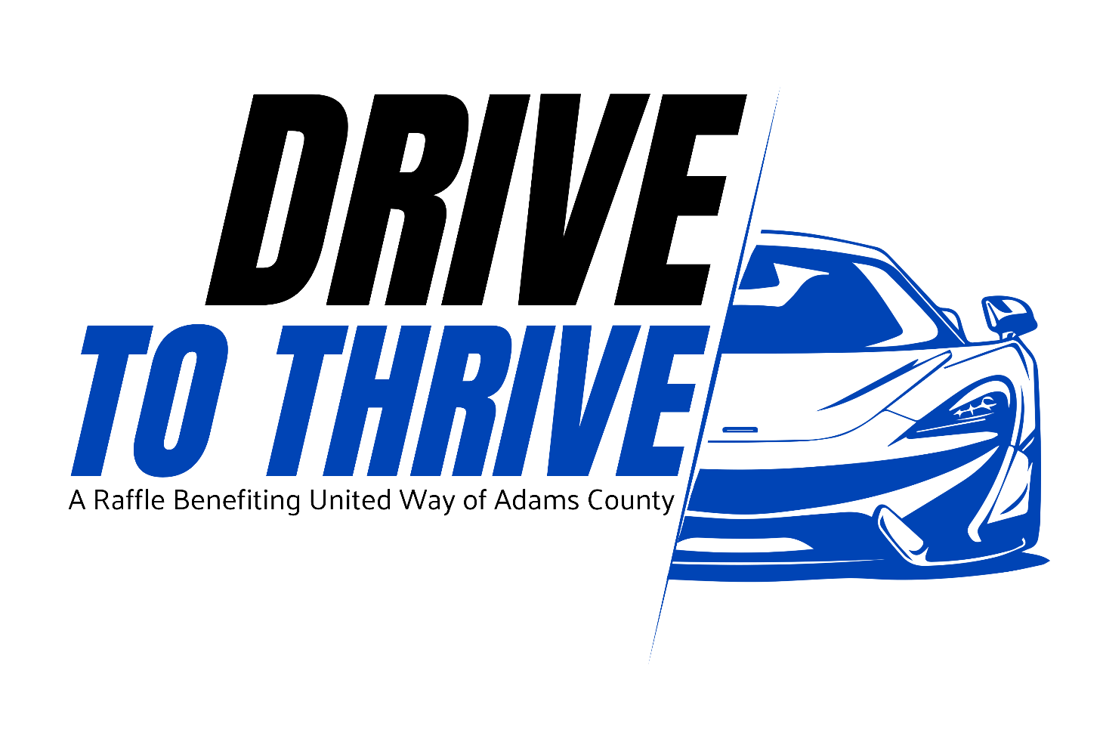

OFFICIAL RULES AND REGULATIONS OF THE DRIVE TO THRIVE RAFFLE

1. Raffle Sponsor and Purpose
The Drive to Thrive Raffle is sponsored and conducted by United Way of Adams County (“UWAC”), 936 Broadway Street, Suite F, Quincy, Illinois 62301.
The Raffle commences at 12:00 a.m. on Thursday, October 1, 2026, and concludes at 8:00 p.m. on Monday, January 11, 2027, unless otherwise required by applicable law or the terms of any applicable raffle license.
The Raffle will be conducted pursuant to one or more raffle licenses issued to UWAC by the appropriate governmental licensing authority or authorities. The Raffle shall be conducted in accordance with the Illinois Raffles and Poker Runs Act, 230 ILCS 15, applicable local ordinances, the terms and conditions of all applicable raffle licenses, and these Official Rules.
United Way of Adams County is an Illinois not-for-profit corporation and an organization exempt from federal income taxation under Section 501(c)(3) of the Internal Revenue Code. Net proceeds from the Raffle will benefit UWAC and will be used solely for its charitable purposes.
By purchasing a Raffle ticket, each purchaser and entrant agrees to be unconditionally bound by these Official Rules, applicable law, and the decisions of UWAC and the Raffle Manager concerning the administration and conduct of the Raffle.

2. Raffle Manager
The Raffle shall be administered under the supervision of Maddie Weed, Raffle Manager, or another individual designated by UWAC if necessary.
The Raffle Manager shall be responsible for maintaining the official Raffle records, overseeing ticket sales and registration, supervising the drawings, maintaining the registry of ticket owners, and performing other administrative duties necessary for the proper conduct of the Raffle.
All drawings shall be conducted in accordance with applicable law and under the supervision of the Raffle Manager or UWAC representative designated by the Raffle Manager.

3. Eligibility
The Raffle is open only to individuals who are at least twenty-one (21) years of age at the time of ticket purchase.
NO PERSON UNDER THE AGE OF 21 MAY PURCHASE, POSSESS, OR BE REGISTERED AS THE OWNER OF A RAFFLE TICKET.
By purchasing a ticket, the purchaser represents and warrants that he or she is at least twenty-one (21) years of age and legally eligible to participate in the Raffle.
The following individuals are not eligible to purchase tickets or win prizes:
- The President and Chief Executive Officer of UWAC;
- UWAC employees and staff members;
- Immediate family members of the individuals listed above, including spouses, parents, children, siblings, and members of their household; and
- Any other person prohibited from participating by applicable law, regulation, raffle license, or local ordinance.
UWAC reserves the right to determine eligibility and to disqualify any individual who does not satisfy the eligibility requirements.

4. Ticket Price and Purchase
Each Raffle ticket costs $200.00.
Tickets may be purchased online through the official Drive to Thrive Raffle webpage or through any other sales method authorized by UWAC and permitted under the applicable raffle license.
All ticket purchasers must be at least twenty-one (21) years of age.
Payment must accompany the purchase of a ticket. Accepted forms of payment may include those payment methods designated by UWAC.
Each ticket will be separately numbered in serial form. Upon receipt and registration of a valid ticket purchase, UWAC will provide the purchaser with a confirmation postcard or other written or electronic confirmation identifying the purchaser and the serial number assigned to the ticket.
A maximum of 1,000 tickets will be sold.
Once the maximum number of tickets authorized for sale has been reached, no additional tickets will be issued or registered. Any payment received after the authorized maximum number of tickets has been sold will be returned to the purchaser.
All ticket sales are final. No refunds will be issued except at the sole discretion of UWAC or as otherwise required by applicable law.
A ticket is not considered valid or eligible for any drawing unless the ticket has been fully paid for and properly registered in UWAC's official Raffle records.

5. Ticket Registration and Ownership
UWAC shall maintain a registry containing the name, mailing address, telephone number, and other information reasonably necessary to administer the Raffle for the registered owner of each ticket sold.
Prizes will be awarded only to the registered owner of the winning ticket.
UWAC is not responsible for disputes concerning ownership of a ticket when the ticket has been properly registered in UWAC's records.
If a ticket is purchased as a gift, the purchaser must provide the recipient's information for registration at the time of purchase or in accordance with procedures established by UWAC. The registered owner must meet all eligibility requirements, including the minimum age of twenty-one (21).
Tickets may not be transferred, assigned, or resold except as expressly permitted by UWAC and applicable law.

6. Drawings
Ten (10) random drawings will be conducted during the Raffle under the supervision of the Raffle Manager or a UWAC representative designated by the Raffle Manager.
Entrants do not need to be present to win.
Each valid and eligible ticket will be eligible for all applicable drawings unless it has already been selected as a winning ticket. A ticket selected in one of the first ten prize drawings will not be eligible to win another of the first ten prizes.
The method used to conduct the random drawings shall be determined by UWAC and the Raffle Manager and shall be conducted in a manner consistent with applicable law and the requirements of the applicable raffle license.
The decisions of UWAC and the Raffle Manager concerning the administration, conduct, and results of the drawings shall be final, subject to applicable law.

7. Prizes
The following prizes will be awarded:
Grand Prize — One (1) 2026 Honda Civic Sport
One (1) eligible ticket holder will be selected to receive a 2026 Honda Civic Sport.
The specific vehicle, including model, trim, equipment, and other specifications, will be identified by UWAC and/or the applicable raffle license.
The Grand Prize winner is solely responsible for all costs and expenses associated with accepting, taking possession of, and maintaining the vehicle, including, without limitation:
- Federal, state, and local taxes;
- Sales or use taxes;
- Title fees;
- License and registration fees;
- Documentation fees;
- Insurance;
- Transportation or delivery costs not expressly provided by UWAC; and
- Any other costs or expenses associated with the vehicle after award.
UWAC makes no representation or warranty regarding the vehicle beyond any warranty expressly provided by the vehicle manufacturer or dealer.
The Grand Prize is not transferable and may not be redeemed for cash, except if required by applicable law or if UWAC determines that substitution is necessary because the advertised vehicle becomes unavailable, subject to any required approval from the applicable licensing authority.
Nine (9) Custom Watches
Nine (9) additional eligible ticket holders will each receive one (1) custom watch by Illinois Watch Company courtesy of Wine on Broadway.
The specific design, model, materials, and specifications of the watches are determined by UWAC and/or Illinois Watch Company and may be subject to availability.
No cash substitution will be permitted unless required by law or determined necessary by UWAC.
Participation Prizes
All eligible ticket holders who are not selected among the ten (10) winners above will receive a participation prize consisting of one (1) bottle of wine or whiskey, courtesy of Wine on Broadway, subject to availability and applicable law.
ALL RECIPIENTS OF ALCOHOLIC BEVERAGE PRIZES MUST BE AT LEAST TWENTY-ONE (21) YEARS OF AGE.
Because all ticket purchasers must be at least twenty-one (21), no alcoholic beverage prize will be awarded to any person under the age of twenty-one (21).
UWAC reserves the right to substitute a comparable alcoholic beverage of substantially similar value if a particular wine or whiskey is unavailable, subject to applicable law.

8. Unlocking Potential Gala Tickets
Each of the ten (10) winners selected in the Grand Prize and nine (9) custom watch drawings will also receive two (2) admission tickets—one ticket for the winner and one guest—to the United Way of Adams County Unlocking Potential Gala scheduled for February 5, 2027.
The Gala tickets have no cash value, are non-transferable unless otherwise determined by UWAC, and are subject to any event-specific terms, conditions, seating limitations, and availability established by UWAC.
The guest accompanying a Gala ticket recipient is not required to be the same individual as the registered ticket purchaser and does not receive any additional Raffle prize or benefit by virtue of attending the Gala.
At the Gala, each of these 10 finalists will receive a key to open a box and reveal which of the top 10 prizes they have won.

9. Winner Notification
The ten (10) finalists will be announced publicly on or about January 15, 2027, and will be notified by telephone, mail, or other reasonable means using the contact information provided by the entrant.
UWAC will make reasonable, good-faith efforts to contact each winner.
If a winning entrant cannot be located or fails to respond to UWAC's good-faith attempts to contact the entrant by 4:30 p.m. on March 31, 2027, the prize may be deemed forfeited.
If a prize is forfeited, UWAC may award the prize to an alternate eligible ticket holder selected through a random drawing, if permitted by applicable law and the applicable raffle license. If an alternate winner is selected, that individual will be subject to the same eligibility and notification requirements.
All decisions regarding the notification and verification of winners shall be made by UWAC and the Raffle Manager and shall be final, subject to applicable law.

10. Distribution of Participation Prizes
All eligible ticket holders who are not among the ten (10) finalists will be contacted by a UWAC representative or the Raffle Manager during February 2027 regarding arrangements for claiming their participation prize.
Participation prizes may be claimed at the United Way of Adams County office located at:
United Way of Adams County
936 Broadway Street, Suite F
Quincy, Illinois 62301
Prizes must be claimed in accordance with UWAC's prize-claim procedures.
Proof of identity and age may be required before any prize is released.
Because participation prizes may include alcoholic beverages, UWAC will not release an alcoholic beverage prize to any person who cannot provide satisfactory proof that he or she is at least twenty-one (21) years of age.

11. Taxes and Expenses
Each prize winner is solely responsible for any and all federal, state, and local taxes arising from or associated with the receipt or use of a Raffle prize.
The Grand Prize winner is specifically responsible for all tax, title, license, registration, insurance, and other governmental or dealer fees associated with the 2026 Honda Civic Sport.
UWAC will report prizes to governmental authorities as required by law. Winners may be required to provide a valid Social Security number or other taxpayer identification information and complete applicable tax forms before receiving a prize.

12. Disqualification
UWAC and the Raffle Manager reserve the right to disqualify any entry or entrant if the entry or entrant is determined to be ineligible or if the ticket:
- Was obtained through fraud, theft, misrepresentation, or other improper means;
- Was not properly paid for;
- Was not properly registered;
- Contains materially inaccurate or incomplete information;
- Is associated with an individual who does not meet the eligibility requirements;
- Results from a violation of these Official Rules, applicable law, or the terms of an applicable raffle license; or
- Contains any other material defect that, in the reasonable judgment of UWAC or the Raffle Manager, makes the awarding of a prize improper, illegal, or impractical.
UWAC and the Raffle Manager may require reasonable documentation to verify the identity and eligibility of a winner before awarding any prize.

13. Limitation of Liability
UWAC, the Raffle Manager, their officers, directors, employees, volunteers, representatives, agents, sponsors, vendors, and other persons materially participating in the conduct of the Raffle shall not be liable for any loss, damage, claim, expense, or injury arising from or relating to the Raffle or the acceptance, possession, use, misuse, or redemption of any prize, except to the extent such liability cannot lawfully be excluded.
UWAC and the Raffle Manager shall not be liable for losses or claims arising from defective printing, lost, stolen, damaged, delayed, misdirected, incomplete, or otherwise defective tickets, payment records, mailings, communications, or other materials, except that UWAC may, in its sole discretion and subject to applicable law, refund the purchase price of an affected ticket.
UWAC is not responsible for technical failures, website outages, internet interruptions, telecommunications failures, unauthorized intervention, or any other circumstance beyond UWAC's reasonable control that affects the purchase, registration, administration, or conduct of the Raffle.

14. Release and Waiver
By purchasing a ticket and participating in the Raffle, each entrant agrees, to the fullest extent permitted by law, to release and hold harmless UWAC, the Raffle Manager, their respective officers, directors, employees, volunteers, representatives, agents, sponsors, vendors, and affiliated persons from any and all claims, demands, liabilities, losses, damages, costs, and expenses arising out of or relating to:
- Participation in the Raffle;
- The conduct or administration of the Raffle;
- Any drawing or determination of a winning ticket;
- The acceptance, possession, use, misuse, or redemption of any prize; or
- Any failure, delay, or interruption in the operation of the Raffle.
In no event shall an entrant be entitled to recover damages in excess of the purchase price actually paid for the affected Raffle ticket, except where such limitation is prohibited by law.

15. Publicity and Use of Name and Likeness
By accepting a prize, each winner grants UWAC and its authorized representatives permission, without additional compensation, to use the winner's name, photograph, likeness, voice, city of residence, and statements relating to the Raffle for advertising, promotional, publicity, social media, website, and other communications relating to the Drive to Thrive Raffle and UWAC, except where prohibited by law.
UWAC is not obligated to use any winner's name or likeness.

16. Privacy
Personal information collected in connection with the Raffle will be used primarily for the administration of the Raffle, including ticket registration, winner notification, prize distribution, accounting, tax reporting, legal compliance, and other purposes reasonably necessary to conduct the Raffle.
UWAC will not sell or otherwise knowingly provide entrants' personal information to unrelated third parties for their independent marketing purposes, except as permitted or required by law or as reasonably necessary to administer the Raffle, process payments, provide prizes, comply with legal or tax obligations, or protect UWAC's legal rights.
By purchasing a ticket, the entrant consents to UWAC's collection and use of information as reasonably necessary to administer the Raffle.

17. Changes, Cancellation, or Interruption
UWAC reserves the right to modify or amend these Official Rules when reasonably necessary to comply with applicable law, regulations, licensing requirements, or circumstances beyond UWAC's reasonable control.
No material change to the Raffle, including changes to prizes, drawing procedures, eligibility, or the Raffle Period, will be made except as permitted or required by applicable law and the terms of the applicable raffle license.
UWAC does not intend to extend the Raffle Period beyond January 11, 2027, except if an extension is required or permitted by applicable law or by the applicable licensing authority.
If the Raffle must be cancelled, suspended, or materially altered because of circumstances beyond UWAC's reasonable control or because continuation would violate applicable law or licensing requirements, UWAC will take such action as is reasonably necessary and legally permitted to address the circumstances.

18. Governing Law and Venue
The Drive to Thrive Raffle is subject to all applicable federal, state, and local laws, regulations, ordinances, and licensing requirements.
These Official Rules shall be governed by and construed in accordance with the laws of the State of Illinois, without regard to conflict-of-law principles.
Any dispute arising out of or relating to the Raffle, these Official Rules, or the conduct of the Raffle shall be brought in a court of competent jurisdiction located in Adams County, Illinois, unless otherwise required by applicable law.

19. Official Rules and Winners List
The current Official Rules for the Drive to Thrive Raffle will be available on the official United Way of Adams County website and the official Drive to Thrive Raffle webpage once established.
A copy of these Official Rules may also be obtained by contacting or visiting:
United Way of Adams County
936 Broadway Street, Suite F
Quincy, Illinois 62301
A list of the ten (10) Grand Prize and custom watch winners will be made available through the official Drive to Thrive Raffle webpage following the February 5, 2027 event, subject to applicable law and UWAC's privacy practices.

20. Severability
If any provision of these Official Rules is determined to be invalid, unlawful, or unenforceable by a court or governmental authority of competent jurisdiction, that provision shall be modified or severed to the minimum extent necessary, and the remaining provisions shall remain in full force and effect.

21. Entire Agreement
These Official Rules constitute the complete and final agreement between UWAC and each entrant concerning the Drive to Thrive Raffle and supersede any prior or contemporaneous representations concerning the Raffle, except as otherwise required by applicable law or expressly stated in an applicable raffle license.
By purchasing a Drive to Thrive Raffle ticket, each entrant acknowledges that they have read, understood, and agreed to these Official Rules.
DRIVE TO THRIVE RAFFLE
United Way of Adams County
936 Broadway Street, Suite F
Quincy, Illinois 62301

