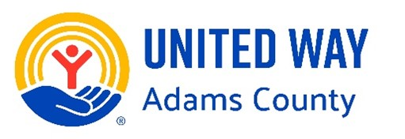
Joe Bonansinga Community Service Award Nomination Form

The Joe Bonansinga “Mr. Quincy” Community Service Award, presented annually by United Way of Adams County and the Rotary Club of Quincy, is awarded to individuals or businesses, that demonstrate outstanding commitment to community impact aligned with the United Way mission to: Inspire, unite, and empower the people of Adams County to reach their full human potential.

The award will be presented at the Rotary Club meeting on Tuesday, May 19, 2026. This award honors exceptional community leaders who demonstrate:
• Lead by example in service
• Inspire and motivate others
• Make a measurable impact
• Demonstrate long-term commitment
• Show selfless dedication to helping others
Nominee (Full Name):

Nominator (your name):

Address:

Cell Phone & Email:
Write a thorough paragraph explaining who you are nominating, and how they exemplify the highest standards of community service as delineated above. Further details will be requested from you, the nominator, (early April) if your nominee becomes a finalist.

DEADLINE FOR NOMINATION FORMS IS WEDNESDAY, APRIL 8TH 2026
Email completed nomination form to maddie@unitedwayadamsco.org or send by mail to: United Way of Adams County
Attention: Joe Bonansinga Award
936 Broadway, Suite F
Quincy, Illinois 62301

